**Experiment No.: 3 Date -06-03-2023**

**Aim**

Familiarisation of Linux Commands

**CO2**

Perform System Aministration tasks

**Procedure**

$pwd



$ls



$ls -R

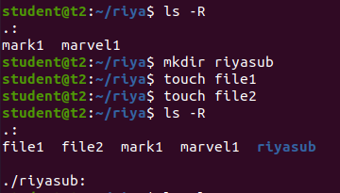

$ls -l

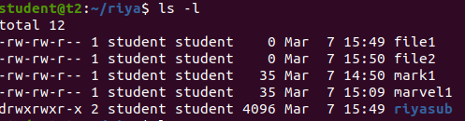

$ls -a



$ls -al

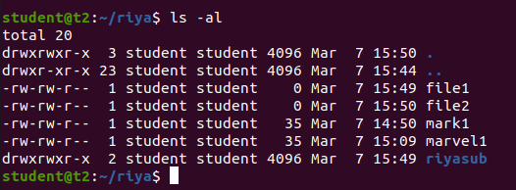

$ls -t



$ls -r



$history

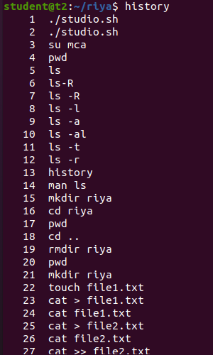

**$ man ls**

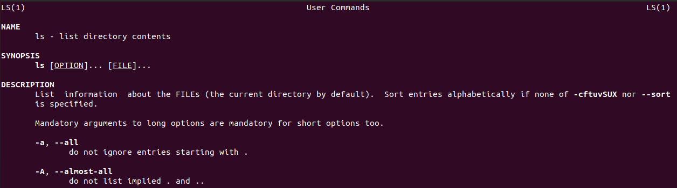

**$mkdir directoryname**



**$ cd ..**



**$ rmdir**

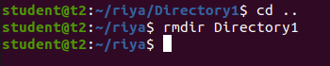

**$touch filename**



**$cat > file1.txt**

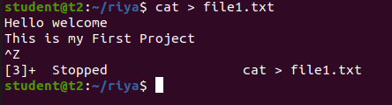

**$cat >> file1.txt**

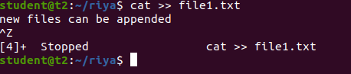

**$cat file1.txt file2.txt > file3.txt**

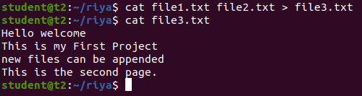

**$cat -n file3.txt**

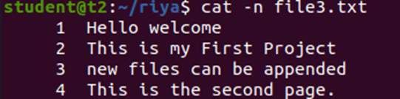

**$cat -b file4.txt**

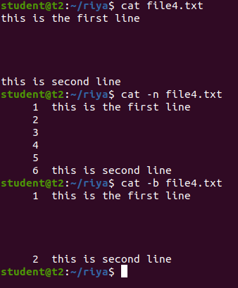

**$cat -e file2.txt**



**$cat c.txt | tr a-z A-Z > output.txt**

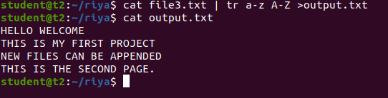

**Result**

The program was executed and the result was successfully obtained. Thus CO2 was obtained.

**Experiment No.: 4 Date -07-03-2023**

**Aim**

Familiarisation of Linux Commands

**CO2**

Perform System Aministration tasks

**Procedure**

$cut -b1 filename

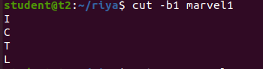

$cut -c3 filename

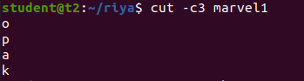

$cut -d ‘ ‘ -f1 filename

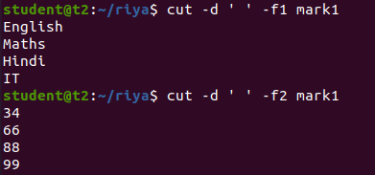

$paste mark1 mark2

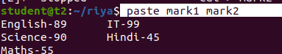

$paste -d ‘-’ mark1 mark2 > mark3

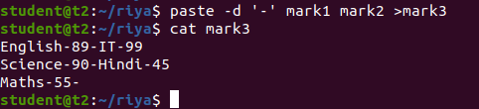

$paste -s mark1



$cp mark1 mark2

(content in mark1 is overwritten in mark2)

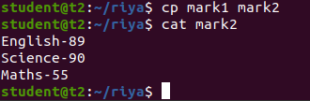

$cp -r riya riya2

(to copy the directory along with its sub directories)

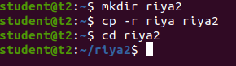

$cp filename directoryname

(to copy file from one directory to another directory)

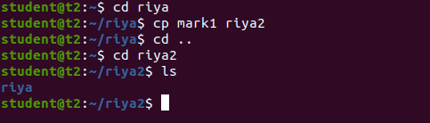

**Result**

The program was executed and the result was successfully obtained. Thus CO2 was obtained.

**Experiment No.: 5 Date -13-03-2023**

**Aim**

Familiarisation of Linux Commands

**CO2**

Perform System Aministration tasks

**Procedure**

$read and echo

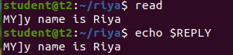

$read var1 var2 var3

(raeding the contents to 3 diffrent variables var1 var2 var3)

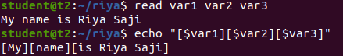

$read (the contents for multiple lines with \ at the end of each line)

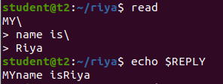

$read -p

(for prompt text from user)

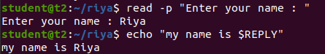

$read - n6

(specifying the limit for the content to read)





$read -s

(security)

and $echo $REPLY (to display the password)



$wc filename



$wc -l filename



$wc -m filename



$wc -c filename



$wc -w filename



$wc -L filename



$more content.txt

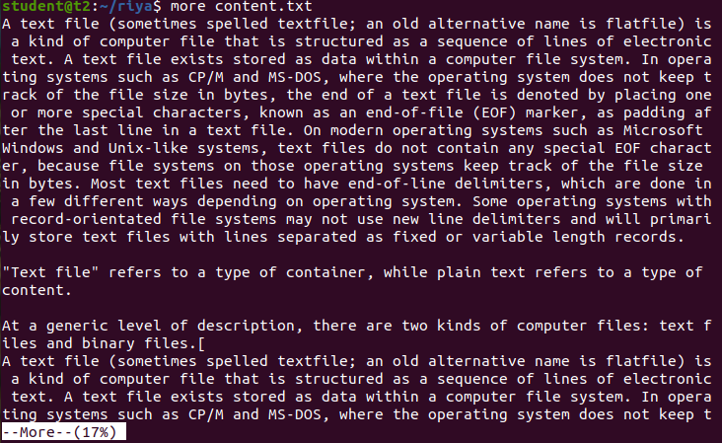

$more +20 content.txt

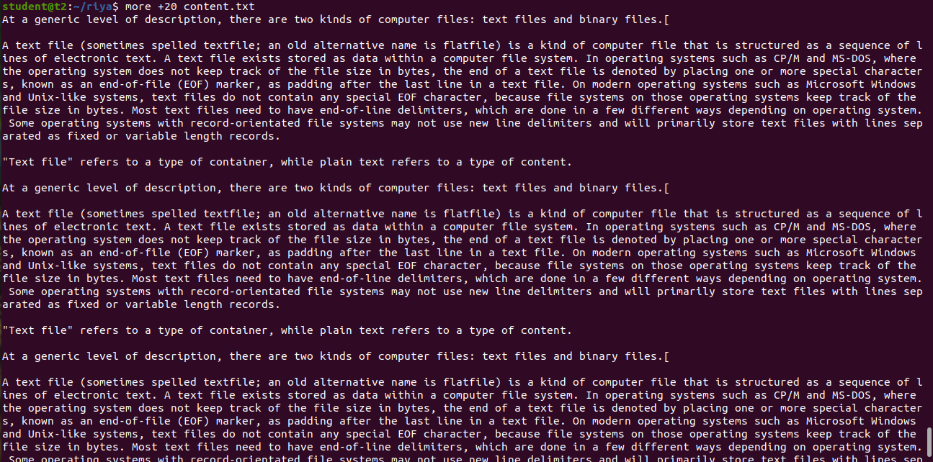

$more +/pattern filename

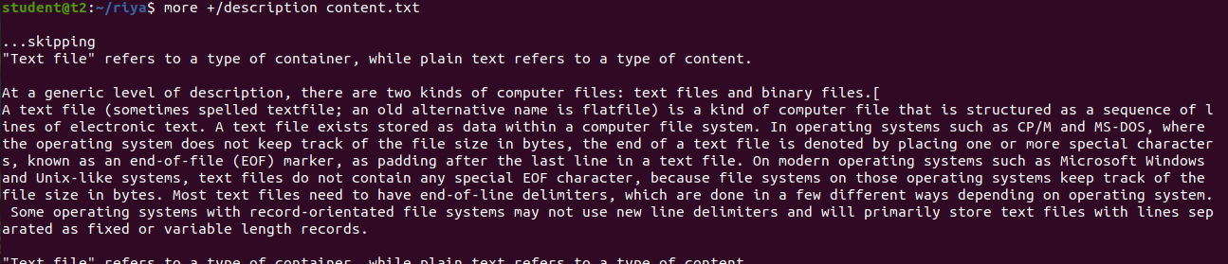

$more -d filename

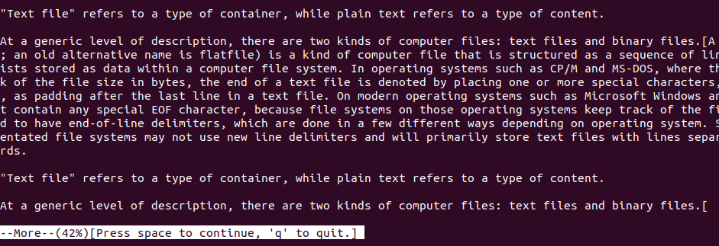

**Result**

The program was executed and the result was successfully obtained. Thus CO2 was obtained.

**Experiment No.: 6 Date -14-03-2023**

**Aim**

Familiarisation of Linux Commands

**CO2**

Perform System Aministration tasks

**Procedure**

$grep -i searchword filename

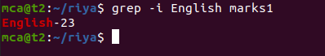

$grep -v searchword filename

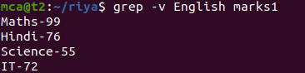

$grep -A1 searchword filename



$grep -B1 searchword filename



$grep -C1 searchword filename

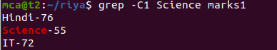

$head filename

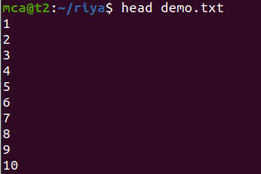

$head -5 filename

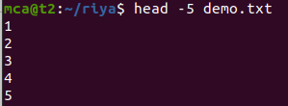

$tail filename

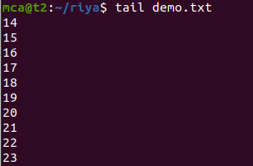

$tail -5 filename

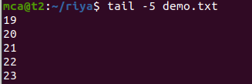

$mv filename filename2

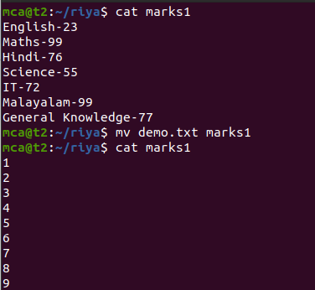

$mv -b filename filename2

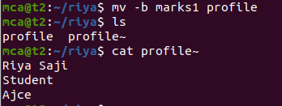

$mv -i filename filename2

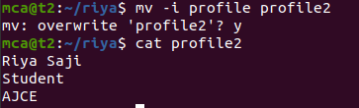

**Result**

The program was executed and the result was successfully obtained. Thus CO2 was obtained.

**Experiment No.: 7 Date -20-03-2023**

**Aim**

Familiarisation of Linux Commands

**CO2**

Perform System Aministration tasks

**Procedure**

$expr 12+8

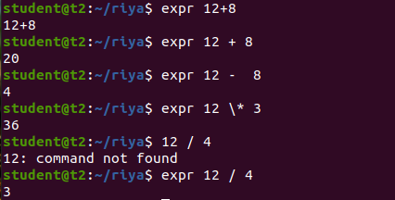

$expr and read

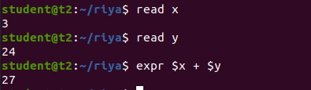

$df

(to check how much space a file or directory takes in current directory)

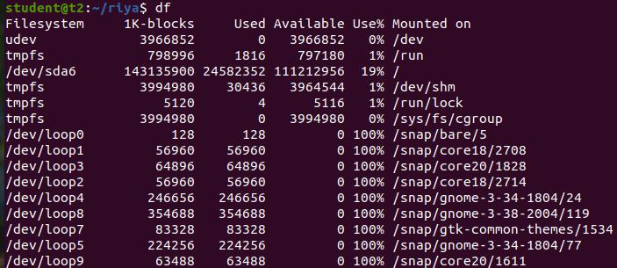

$du filename

(is used to check how much space a file or directory takes in current directory )



$sudo useradd newusername

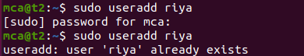

$sudo passwd username

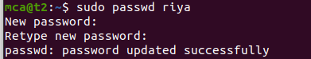

$sudo groupadd -g identifier groupname



$sudo usermod -G groupname username



$id username

(used to find out groupname & numeric id for the user)



$compgen -g

(displays all the existing groups)

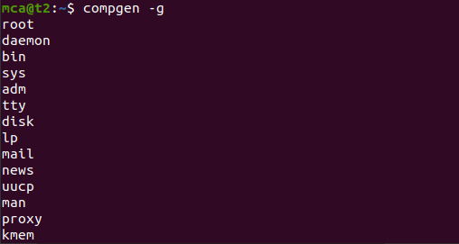

$chmod -wx filename

(to change the mode of permission, here writing and execution permission is denied)



(here writing and execution permission is granted

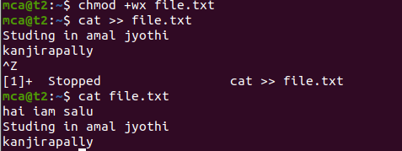

$sudo chown username filename

(to change a file owner or directory ownership for a user or the group)

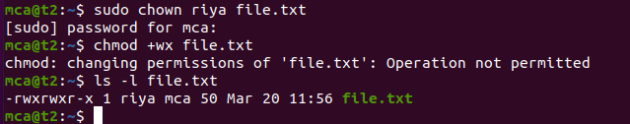

$sudo userdel username

(to delete the user)

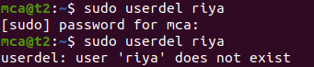

$sudo groupdel groupname

(to delete the group)



**Result**

The program was executed and the result was successfully obtained. Thus CO2 was obtained.

**Experiment No.:8 Date -21-03-2023**

**Aim**

Familiarisation of Linux Commands

**CO2**

Perform System Aministration tasks

**Procedure**

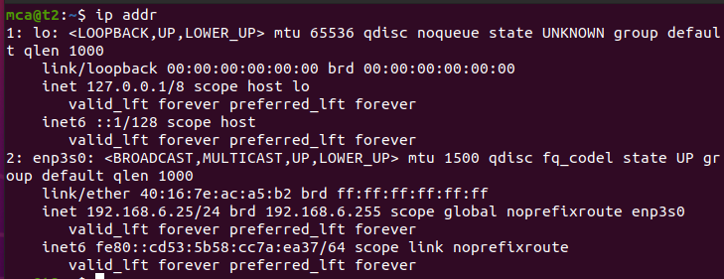

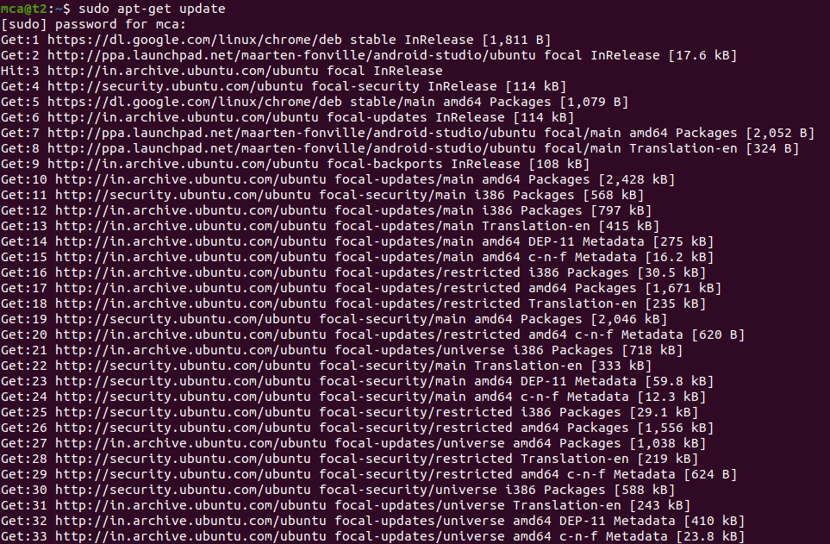

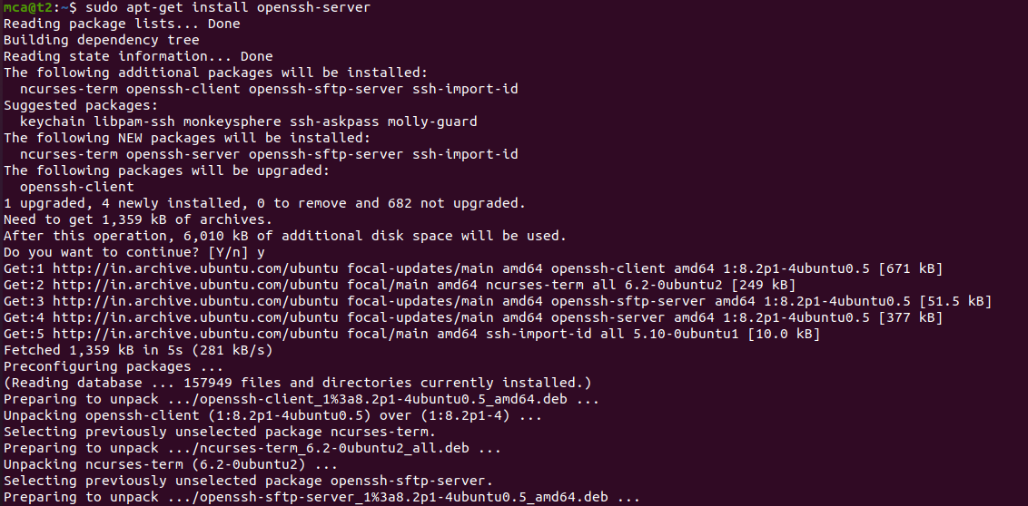

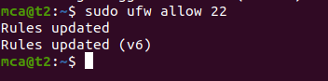

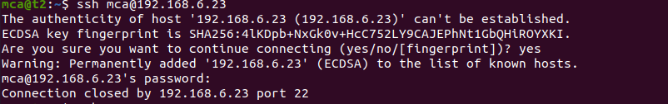

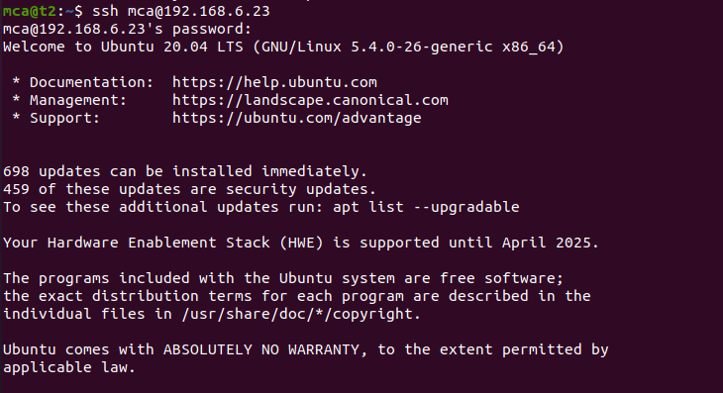



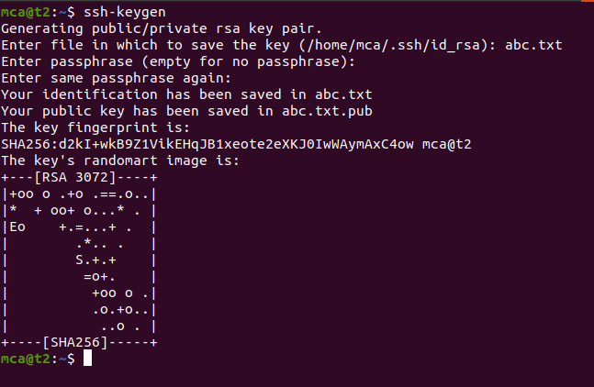

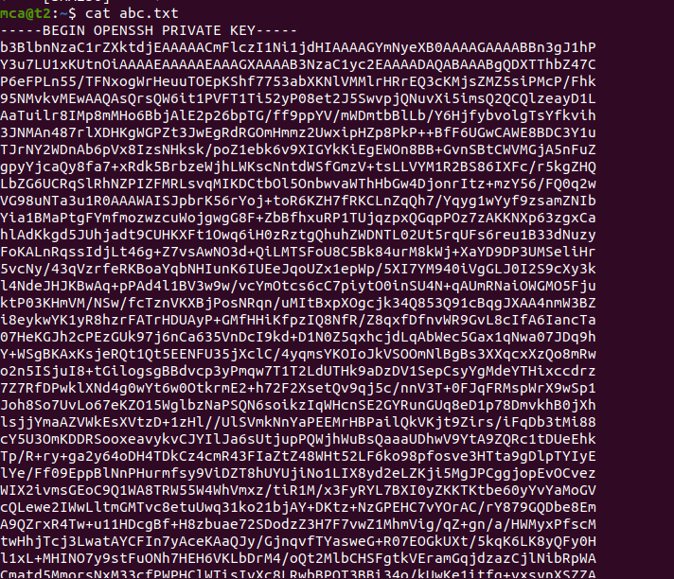

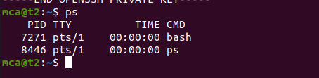

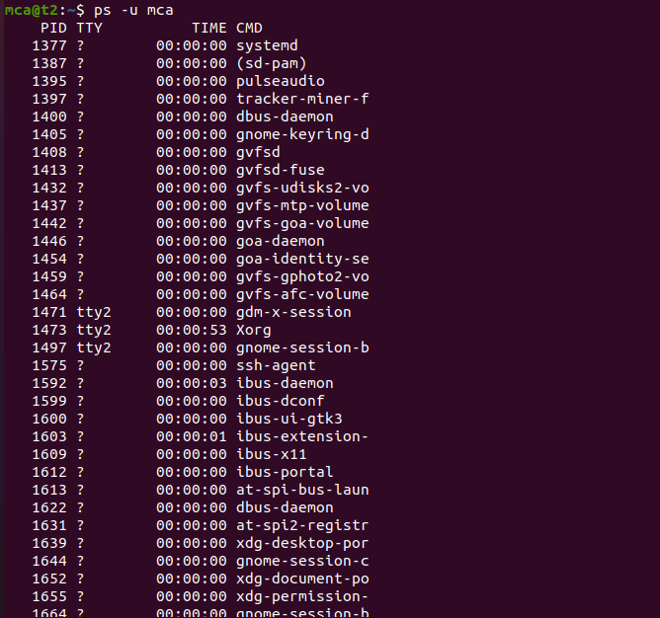

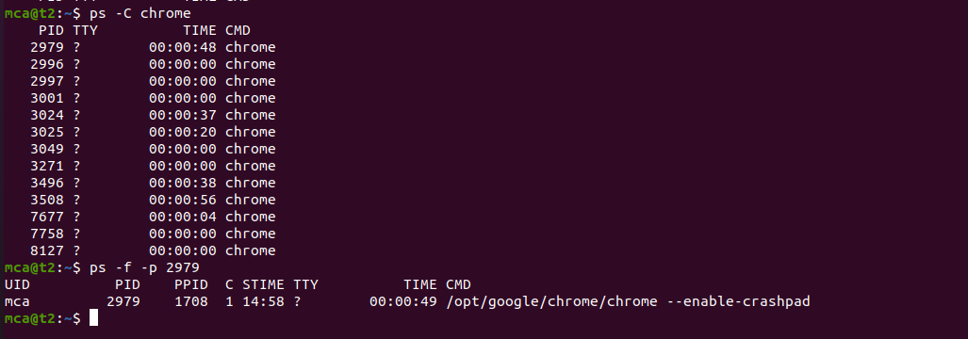

**Result**

The program was executed and the result was successfully obtained. Thus CO2 was obtained.

**Experiment 9 28-03-2023**

**Aim : Shell scripting**

**Procedure**

**1.Shell Script to display the date**

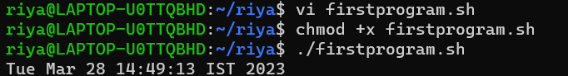

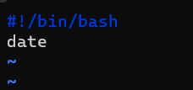

**2.Shell Script to display your name**

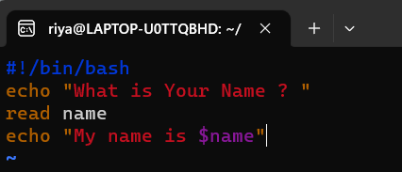

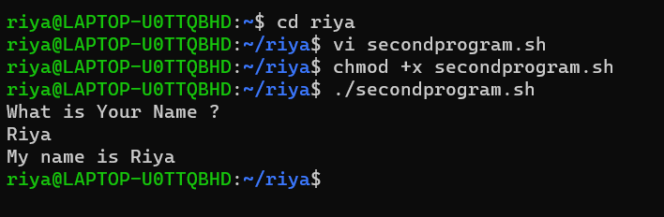

**3.Shell Script to display date , pwd , ls(multiple commands)**

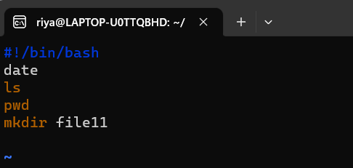

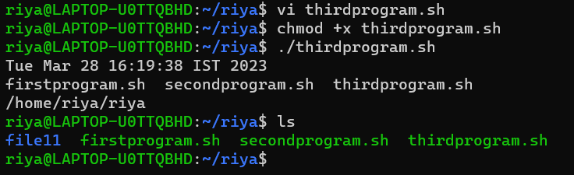

**4.Shell Script to demonstrate special variables**

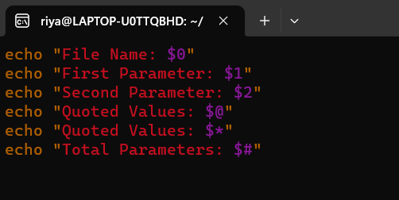

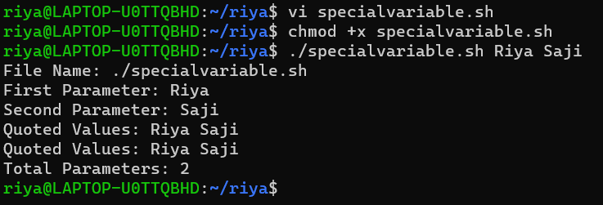

**5.Shell Script to count lines and words of the file**

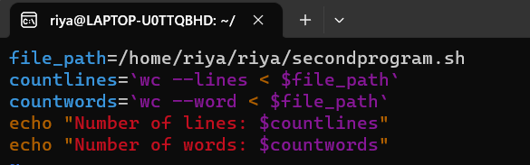

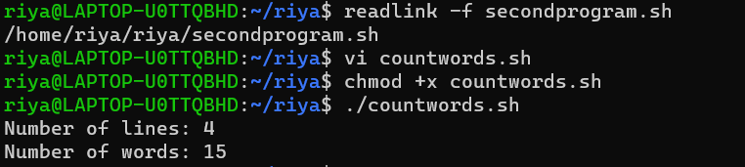

**6.Shell Script to display array index**

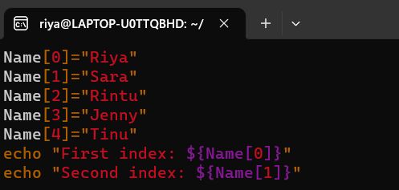

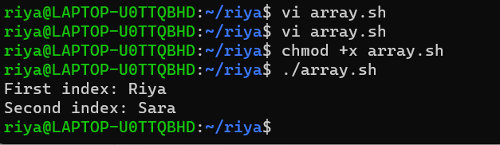

**Experiment 10 03-04-2023**

**Aim : Shell scripting (basic operations)**

**Procedure**

**1.Shell script to add two numbers**

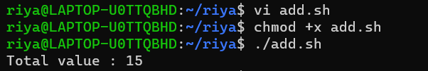

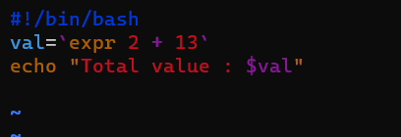

**2.Write an example shell script to intialize two numeric variables . then perform an addition operation on both values and store the result in the third variable**

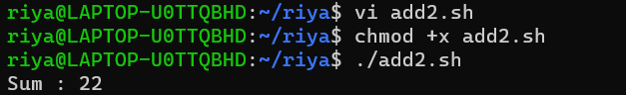

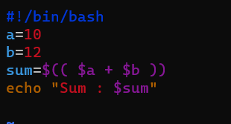

**3. Shell script to read two num,bers as command line parameters and perform the addition operation**

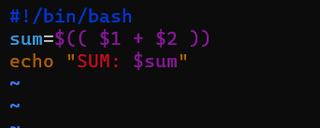

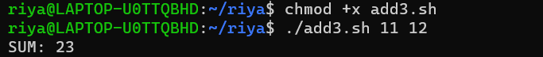

**4.Shell script which takes input from the user at run time . Then calculate the sum of given numbers and store to variable amd show the result**

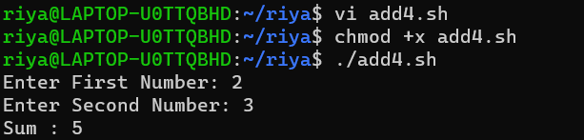

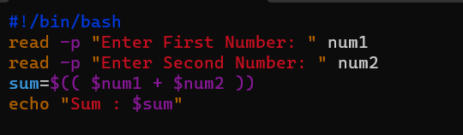

**Experiment 11 04-04-2023**

**Aim : Shell scripting (basic operations)**

**Procedure**

**Shell script to demonstrate arithmetic operations**

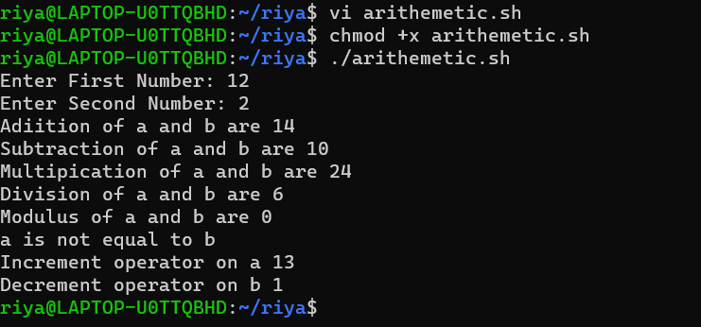

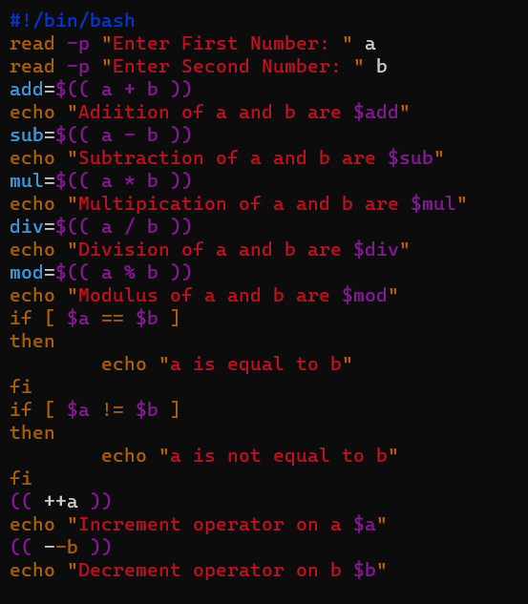

**Shell script to demonstrate Relational operations**

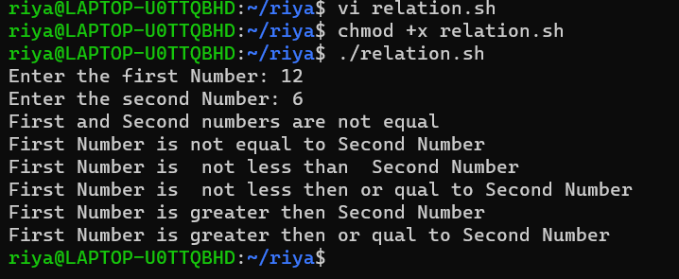

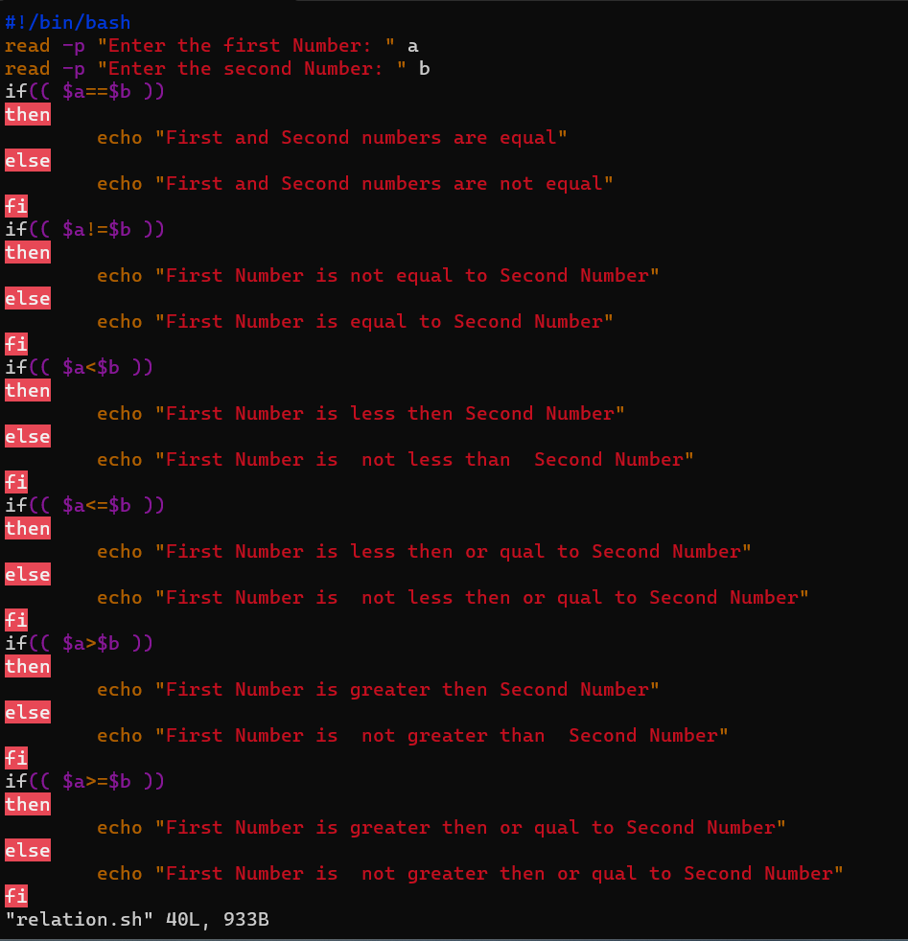

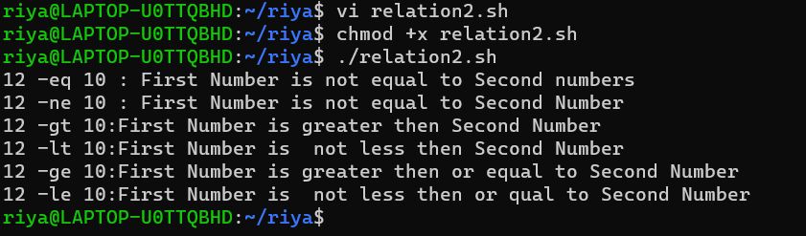

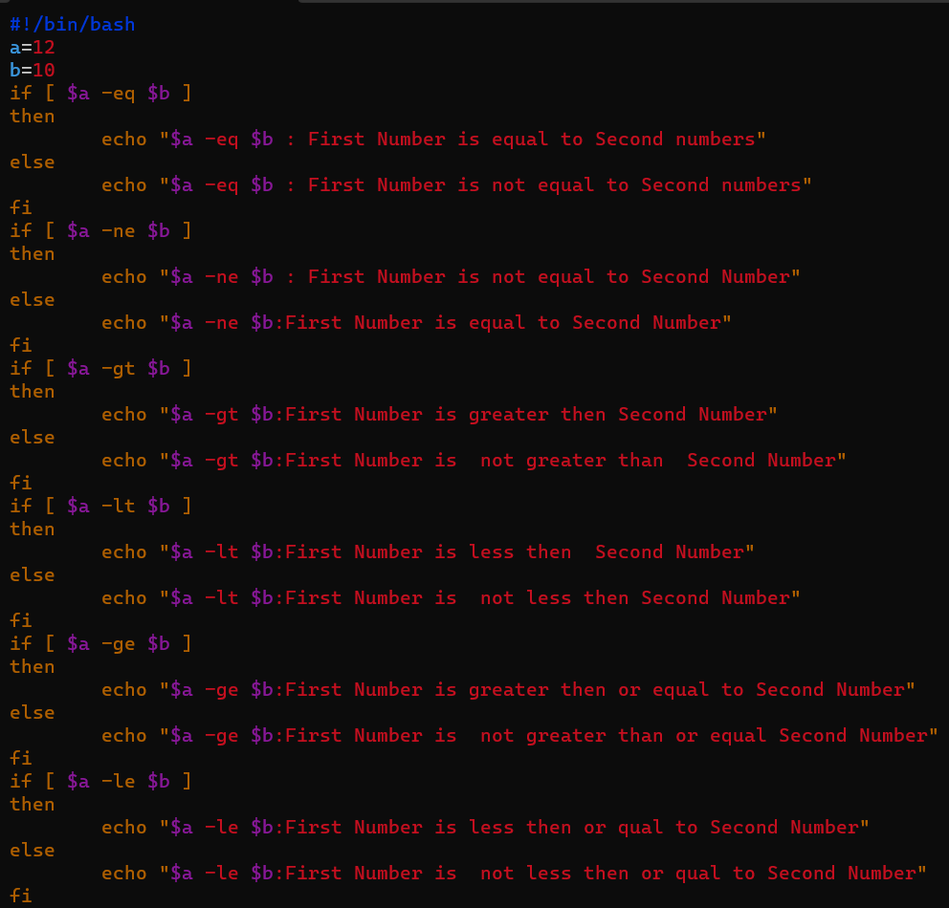

**Shell script to demonstrate Logical operations**

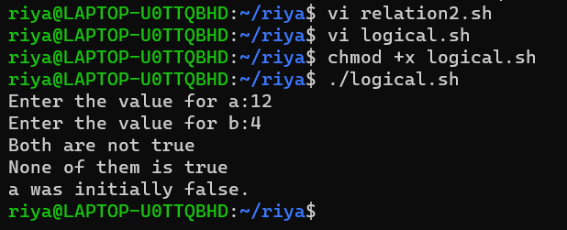

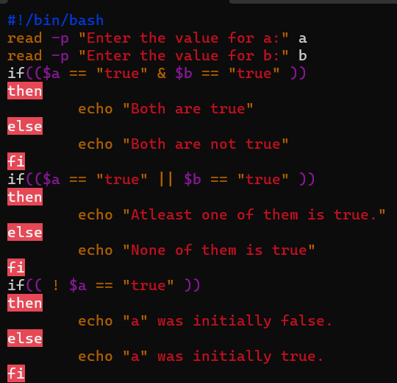

**TO check whether the number is odd or even**

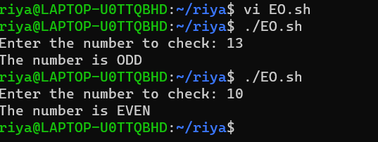

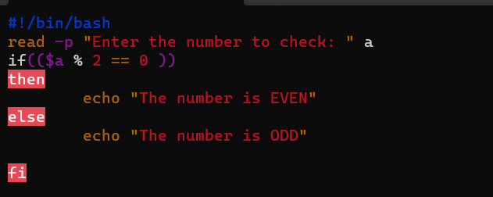

**Write a shell script to Check whether the number is positive or negative**

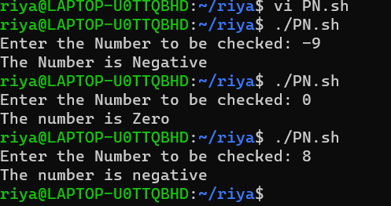

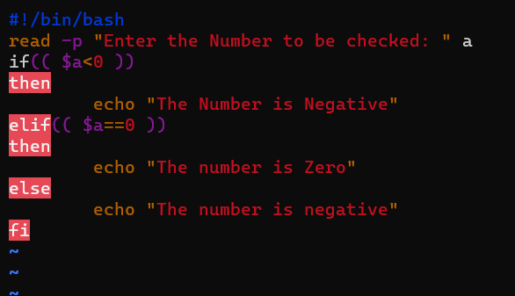

**Write a shell script to find the greatest of two numbers**

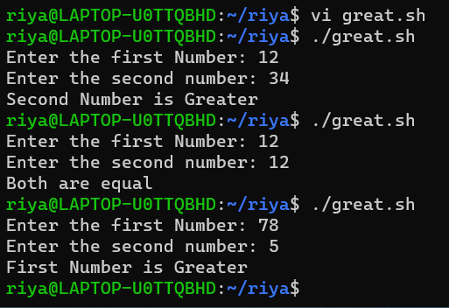

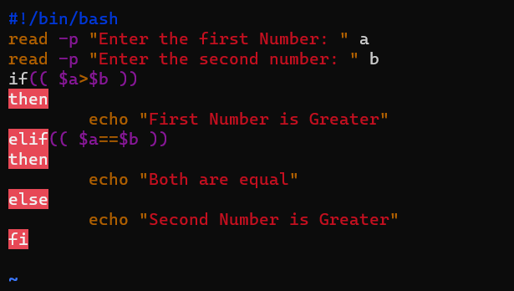

**Write a shell script to find the greatest of THREE numbers**

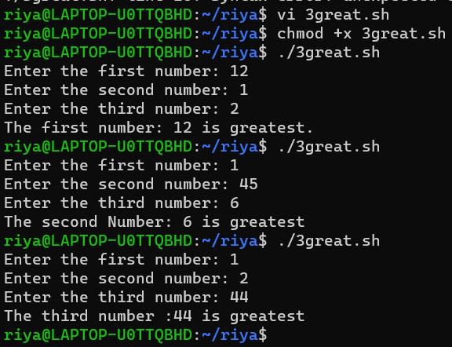

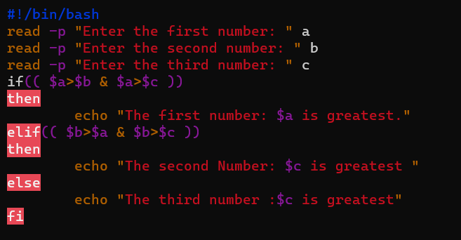

**Experiment 12 11-04-2023**

**Aim : Shell scripting (basic operations)**

**Procedure**

**Shell script to demonstrate String operators (Equal, Not Equals, Size is zero, Size is non-zero, Empty string) by taking user input**

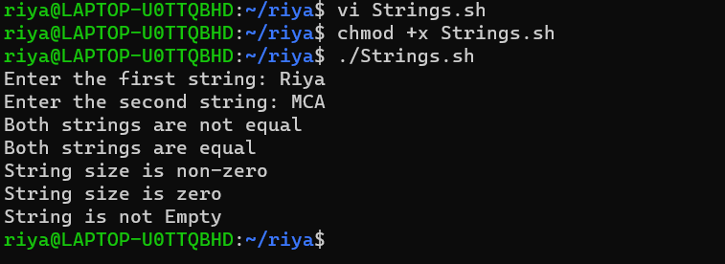

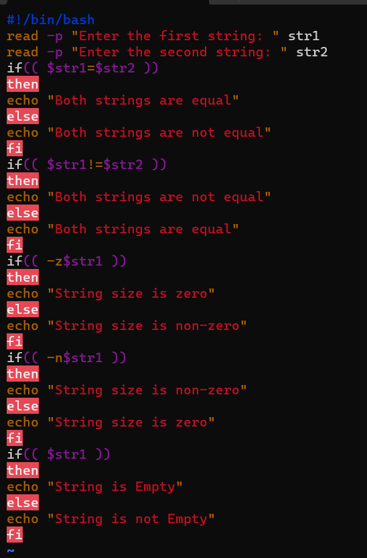

**Shell script to demonstrate Bitwise operators (AND, OR, XOR, Complement, Right Shift, Left Shift) by taking user input**

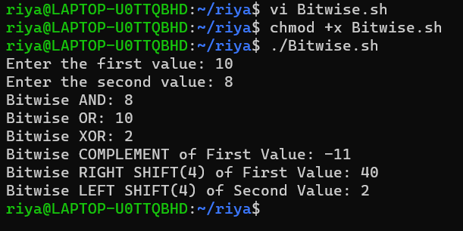

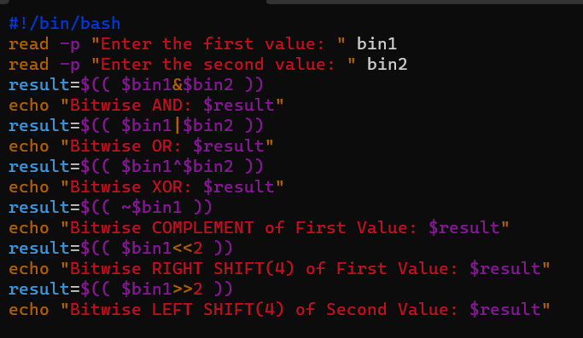

**Shell script to demonstrate File Test operators (Exist(e), Size(s), Read Permission(r), Execute Permission(x), Write Permission(w)) by taking user input**

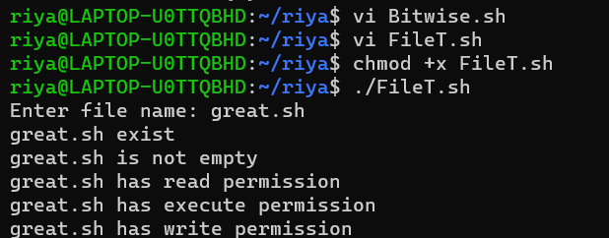

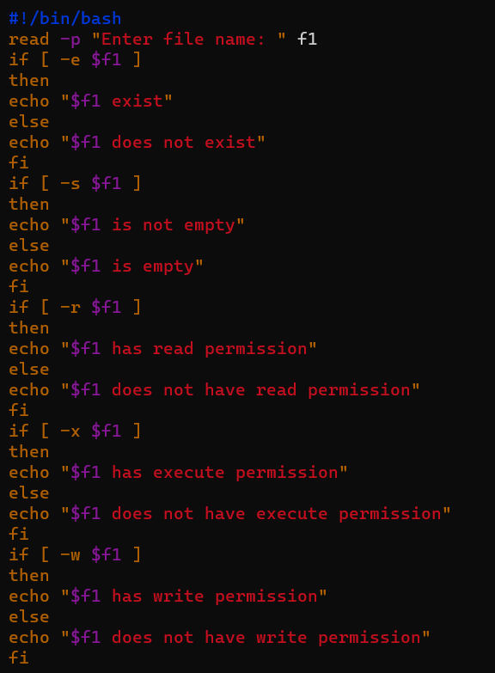

**Shell Script to check if two numbers are equal using if statement**

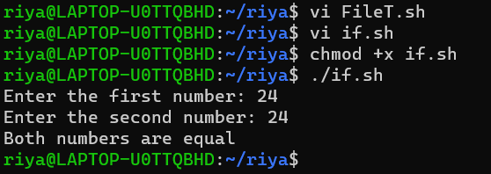

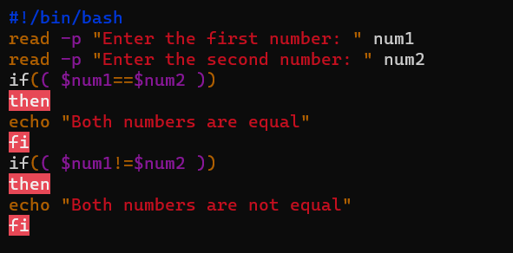

**5. Shell Script to check the range of a number if numbers using else if ladder**

